

1st Year 2nd Semester BSc. (Hons) Final Examination 2019

Institute of Information Technology

**Jahangirnagar University**

Savar, Dhaka-1342

ICT 1200: Course Viva

**Library Management System of IIT**

Submitted To:

**Dr M Mesbahuddin Sarker**

Professor

Institute of Information Technology

Jahangirnagar University

**DECLARATION**

This project report is submitted to the Institute of Information Technology, Jahangirnagar University, Savar, Dhaka in partial fulfillment of the requirements for having the B.Sc (Hons.) degree in ICT. This is also needed to certify that the project work is under the 1st Year 2nd Semester course of the IIT “ICT-1200: Course Viva”. So, we are here declaring that this project report has not been submitted elsewhere for the requirement of any kind of degree, diploma or publication.

Nahidul Islam Md. Shakil Hossain Mahabubur Rahman  
 192345 192340 192341

**ACCEPTANCE**

This project report is submitted to the Institute of Information Technology, Jahangirnagar University, Savar, Dhaka in partial fulfillment of the requirements for having the B.Sc. (Hons.) degree in ICT.

**Dr M Mesbahuddin Sarker**

Professor

Institute of Information Technology (IIT)

Jahangirnagar University

Savar, Dhaka-1342, Bangladesh

**ACKNOWLEDGEMENTS**

First of all we would like to thank the Almighty for giving us the opportunity to complete this work successfully. Our acknowledgement is meant to express our sincere gratitude to all those people who have been associated with this project and have helped us with it and by sharing their experiences and valuable opinions through which we received the required information crucial for our project. We are thankful to our parents for their relentless support. Most importantly we are grateful to our honourable supervisor who took time out to guide us and provide us with all the necessary materials and sufficient knowledge that was the major requirement.

Finally, we convey our regards to our honourable teacher **Dr M Mesbahuddin Sarker** Sir for giving us the opportunity to learn the subject particularly practically.

**ABSTRACT**

Library management system is a project which aims in developing a computerized system to maintain all the daily work of library. This project has many features which are generally not available in normal library management systems like facility of admin login through which the admin can monitor the whole system. The librarian after logging into his account can generate various option such as new student, new book, issue book and return book details.

Overall this project of ours is being developed to help staff of library to maintain the library in the best way possible and also reduce the human efforts.

**CONTENTS**

**Chapter 1: Introduction Pages**

* 1. Introduction 6
  2. Motivation 6
  3. Objectives 7

Chapter 2: Background

* 1. Introduction 8
  2. Related Works 8
  3. Scope of the Problem 9
  4. Challenges 9

Chapter 3: Requirement Specification

3.1 Requirement Collection and Analysis 10

Chapter 4: Implementation and Testing

* 1. Implementation of Database 11
  2. Context diagram 12
  3. Test Results and Reports 13 -16

Chapter 5: Conclusion and Future Scope

* 1. Discussion and Conclusion 17

5.2 Scope for Further Developments 17

**Chapter 1**

**Introduction**

* 1. Introduction:

Modern Generation is going to dependable on computer and through computer we use Software. Hence, we are learning java that’s why we create an Application for managing library system by using java. By using this, we can store a student’s information, issue a book and store a student’s information who take a book from this library. Mainly this application are used by Library administration.

1.2 Motivation:

Libraries are essential in a process of giving citizens access to knowledge. In digital times they are needed more than ever before. In our country, library systems are written that’s why we make a great use of paper. By making paper we cut trees. It is very harmful for our environment. For our environment, we take this step to reduce this.

1.3 Objectives:

The aim of this project is to develop a system that can handle & manage the activities involved in a library in an efficient & reliable way. Less managing personnel & easy searching availability & user profile managing are major goals in this project.

* Develop a system that can replace the manual library managing system.
* Develop a database which stores user details & book details.
* Give reliable search facility for the users.
* Administrator or librarian should have logins.
* Create an easy to understand user friendly environment.
* Attractive user interfaces to navigate through the system for the users.
* Develop the system documentation with detailed UML specifications.

**Chapter 2**

**Background**

2.1 Introduction:

Library Management System is an application which refers to library systems which are generally small or medium in size. It is used by librarian to manage the library using a computerized system where he/she can record various transactions like issue of books, return of books, addition of new books, addition of new students etc.

Books and student maintenance modules are also included in this system which would keep track of the students using the library and also a detailed description about the books a library contains. With this computerized system there will be no loss of book record or member record which generally happens when a non computerized system is used.

All these modules are able to help librarian to manage the library with more convenience and in a more efficient way as compared to library systems which are not computerized.

2.2 Related Works:

* Data base connection.
* Java GUI Application.
* Java swing application.
* Unified modelling language.

2.3 Scope of the Problem:

* + - When connect with Database table .
    - When make a runnable jar file.
    - When make a Exe file.
    - When need to add some of extra jar file.

2.4 Challenges:

* + - Work with database.
    - Make a runnable jar File.
    - Make jar file to exe File.
    - UMl design.
    - Working with java GUI and Swim.
    - Set specific code for different kinds of jbutton, jlabel, jtextfield,jdate,jTable, jpanel etc.

**Chapter 3**

**Requirement Specification**

3.1 Requirement Collection & Analysis:

**Software configuration:**

This software package is developed using java as front end which is supported by sun micro system. Microsoft SQL server is the back end to store the database.

Operating system: Windows 7, 8, 10, 11.

Software: NetBeans 8.2 (front end)

Language: java Runtime Environment,

Database: MySQL Database Service

**Hardware Configuration:**

Processor: Pentium(R) Dual-core CPU to core-i3

Hard Disk: Minimum 4 GB

RAM: 512 MB or more.

**Chapter 4**

**Implementation & Testing**

4.1 Implementation of Database:

package **Project**;

import **java.sql.\***;

import **com.mysql.jdbc.Connection**;

**public** **class** ConnectionProvider {

**public** **static** Connection getCon() {

**try** {

Class.forName("com.mysql.jdbc.Driver");

Connection con = (Connection) DriverManager.getConnection("jdbc:mysql://localhost:3306/lmsi", "root", "Mysql");

**return** con;

} **catch** (Exception e) {

System.out.println(e);

**return** **null**;

}

}

}

4.2 Context Diagram:

Admin

Log in

Home page

Home page

Exit

Log out

Issue Book

New Book

Return Book

New Student

Statistics

4.2 Test Results and Report:

Login

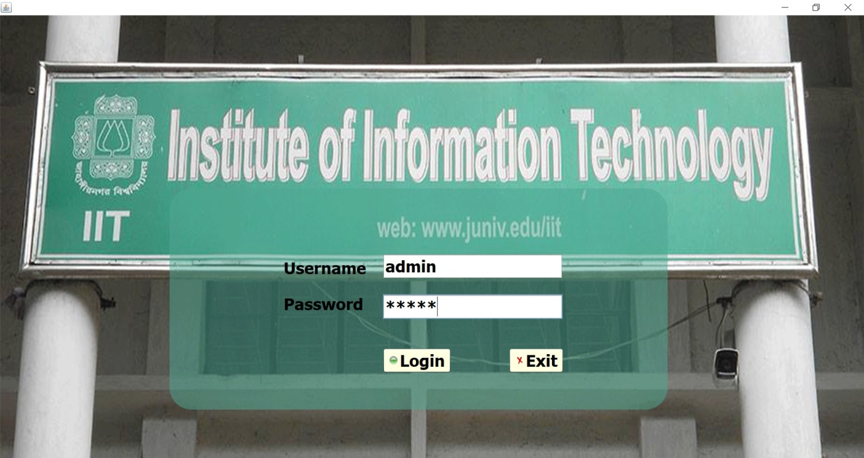

Home

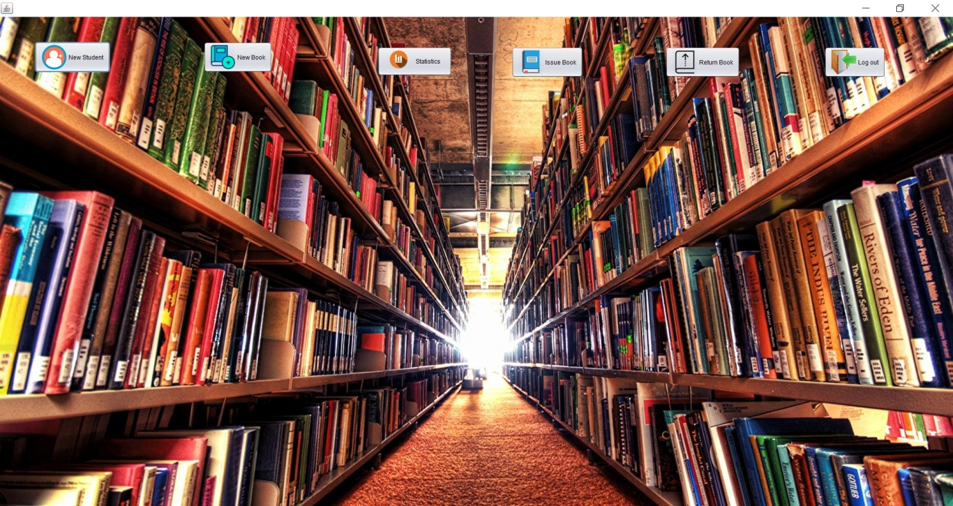

New Student

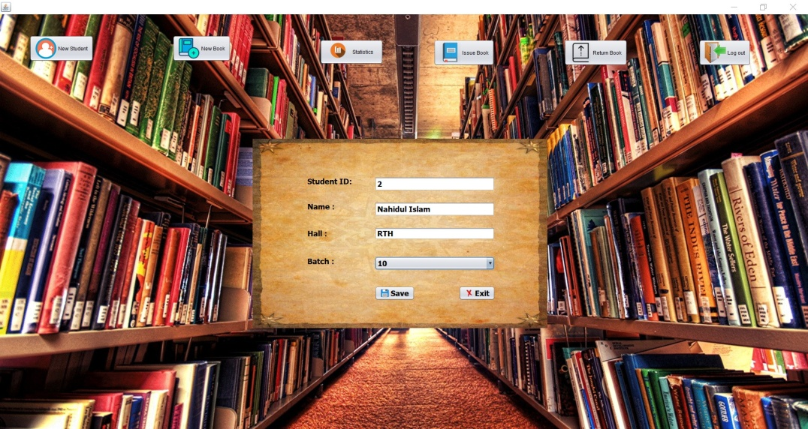

New Book

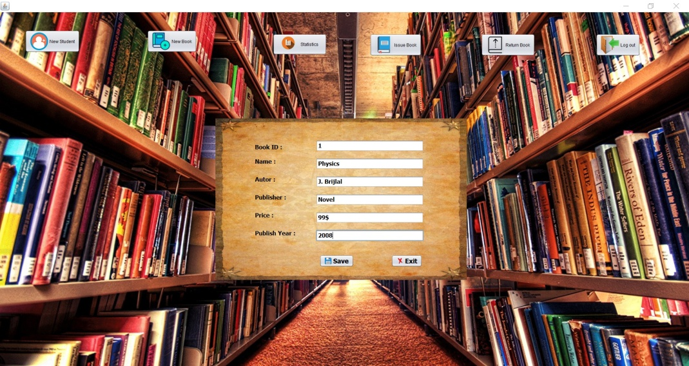

Issue Book

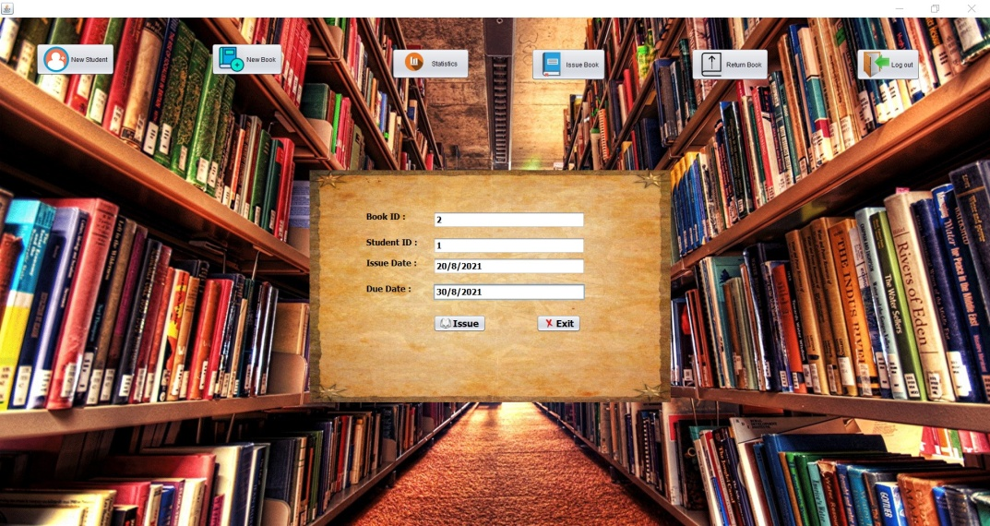

Return Book

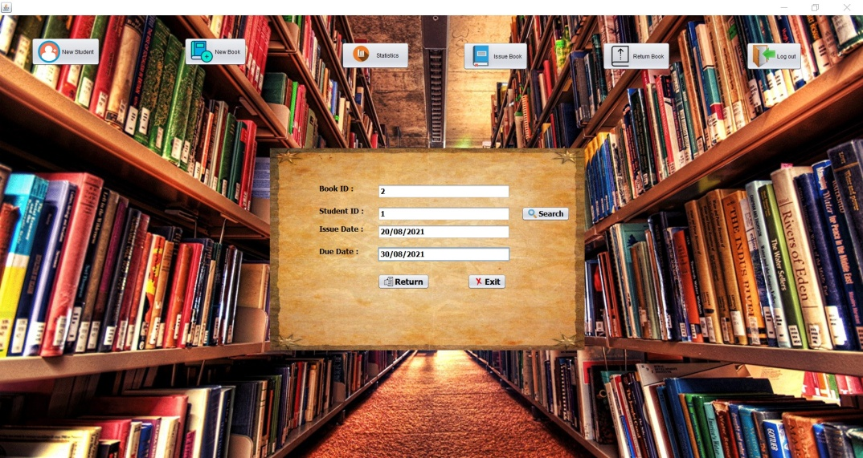

Statistics

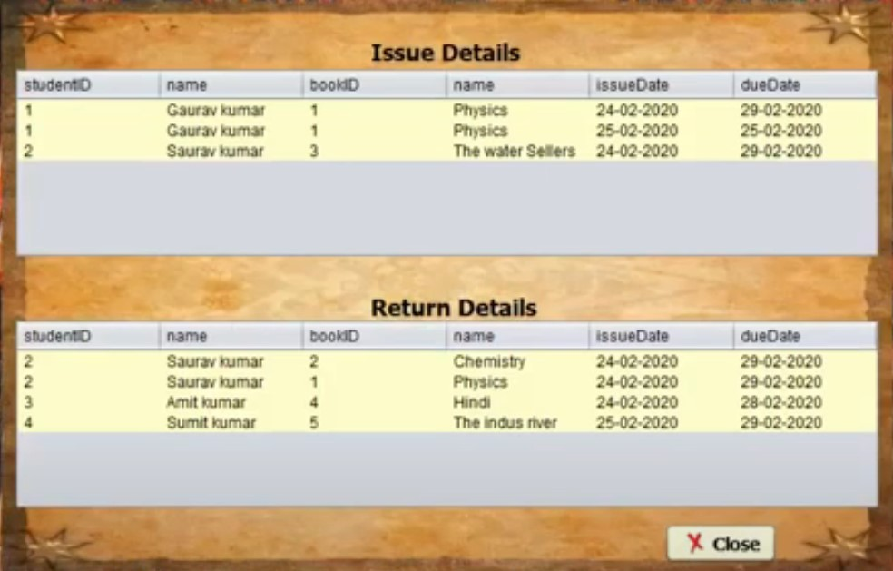

**Chapter 5**

**Conclusion and Future work**

5.1 Discussion & Conclusion:

In this application we can entry a new book which has a specific id, price, pages, book name, publisher. We also add a student’s information such as name, id, father’s name, batch, semester which is help admin when a student issue a book & return a book. If admin wants to see the details information of returning or issuing a book with date, he needs to click just a button on our application.

5.1 Scope for further development:

We have many scope for developing our Application. We can make this application as Server based application. In our application we don’t have student’s interaction to this application. We can make this happen in future. We can make this application as an android application which is very helpful to the user and the library authority.

References

* + 1. <https://netbeans.org/downloads/>
    2. [http://www.oracle.com/technetwork/java/javase/downloads/jdk 8-downloads-2133151.html](http://www.oracle.com/technetwork/java/javase/downloads/jdk8-downloads-2133151.html)
    3. <http://www.jtattoo.net/Download.html>
    4. <http://launch4j.sourceforge.net/>
    5. [https://sourceforge.net/projects/finalangelsanddemons/files/rs2x ml.jar/download](https://sourceforge.net/projects/finalangelsanddemons/files/rs2xml.jar/download)
    6. <https://bitbucket.org/xerial/sqlite-jdbc/downloads/>
    7. <http://www.java2s.com/Code/Jar/j/Downloadjcalendar14jar.htm>
    8. https://www.mysql.com/downloads/
    9. [https://www.youtube.com/playlist?list=PLEAQNNR8IlB4R7NfqBY1 frapYo97L6fOQ](https://www.youtube.com/playlist?list=PLEAQNNR8IlB4R7NfqBY1frapYo97L6fOQ)